**Title: The Impact and Usefulness of Git in Collaborative Software Development**

**Abstract:**

This report explores the pivotal role of Git in modern software development, focusing on its widespread adoption, key features, and the overall impact it has on collaboration within development teams. Git, a distributed version control system, has revolutionized the way developers work together, providing efficient solutions to versioning, branching, and merging. This report aims to highlight the significance of Git in enhancing productivity, enabling collaboration, and ensuring code integrity.

**Introduction:**

Version control systems (VCS) are essential tools for managing source code changes in software development. Git, created by Linus Torvalds in 2005, has emerged as a dominant player in this domain. Its decentralized and distributed nature has significantly influenced collaborative development practices.

**Key Features of Git:**

Distributed Version Control: Git allows developers to work independently and collaboratively, with each contributor having a complete repository. This enables flexibility and autonomy.

Branching and Merging: Branching is lightweight and effortless in Git, facilitating parallel development and experimentation. Merging is seamless, promoting a smooth integration of code changes.

History and Log: Git maintains a detailed history of changes, making it easy to track modifications, understand the evolution of the codebase, and identify contributors.

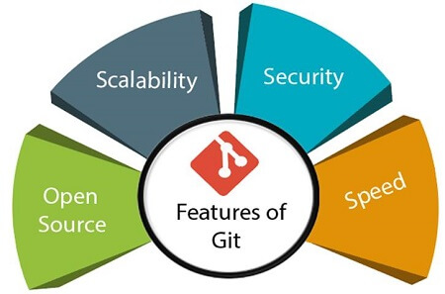

**Productivity Boost:**

Code Integrity: Git ensures code integrity by tracking changes, preventing accidental overwrites, and allowing easy rollbacks. This safeguards the stability and reliability of the codebase.

Efficient Code Reviews: Git's branching and history features facilitate efficient code reviews. Reviewers can navigate through changes, comment on specific lines, and suggest improvements.

**Case Studies:**

Open Source Projects: Many successful open-source projects, such as Linux and Python, rely on Git for version control. Its adaptability to large and distributed teams has contributed to the success of these projects.

Industry Adoption: Leading tech companies and startups adopt Git as the standard version control system due to its effectiveness in managing collaborative development.

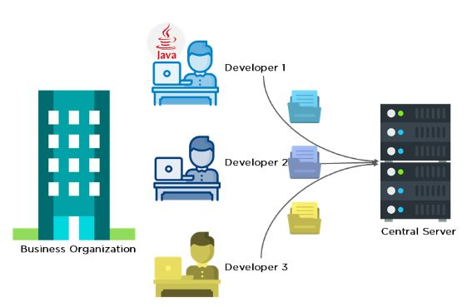

**Conclusion:**

Git has become an indispensable tool in the realm of collaborative software development. Its distributed nature, powerful branching model, and emphasis on code integrity contribute to increased productivity and streamlined collaboration. As the software development landscape continues to evolve, Git remains a fundamental component in shaping efficient and effective development practices.